🔬 EXPERIMENT 1: Interfacing LEDs / Switches with Embedded Core
📄 Source:

Aim
To interface LEDs and switches with an embedded controller and control LED operation based on switch input.

Apparatus Required
- Embedded board (Arduino UNO / 8051 / ARM)
- LED (Red/Green)
- Resistors (220Ω, 10kΩ)
- Push button switch
- Breadboard
- Connecting wires
- Power supply / USB

Theory
- Embedded systems use GPIO (General Purpose Input Output) pins to interact with hardware.
- LED → Output device
  - Glows when GPIO is HIGH
- Switch → Input device
  - Changes logic level when pressed
- Pull-up/pull-down resistors prevent floating input

Circuit Connections
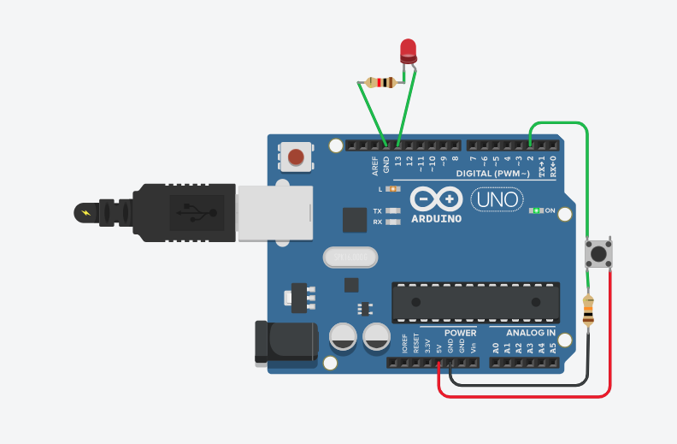
Algorithm
- Start
- Set LED pin as OUTPUT
- Set switch pin as INPUT
- Read switch state
- If pressed → LED ON
- Else → LED OFF
- Repeat
Code
int buttonState = 0;
void setup()
{
pinMode(2, INPUT);
pinMode(LED_BUILTIN, OUTPUT);
}
void loop()
{
buttonState = digitalRead(2);
if (buttonState == HIGH) {
digitalWrite(LED_BUILTIN, HIGH);
} else {
digitalWrite(LED_BUILTIN, LOW);
}
delay(10);
}
Observation
Switch | LED
Pressed | ON
Released | OFF

Conclusion
LED and switch were successfully interfaced using GPIO. LED operation was controlled based on switch input, demonstrating basic digital I/O in embedded systems.

🔬 EXPERIMENT 2: Interfacing DHT11 Temperature & Humidity Sensor with Arduino
📄 Source:

Aim
To interface the DHT11 sensor with Arduino Uno and display temperature & humidity on Serial Monitor.

Apparatus Required
- Arduino Uno
- DHT11 Sensor
- 10kΩ resistor (if bare sensor)
- Breadboard
- Connecting wires
- USB cable
- Arduino IDE
Theory
- DHT11 measures:
  - Temperature
  - Humidity
- Contains:
  - Capacitive humidity sensor
  - Thermistor
  - Internal ADC
- Uses single-wire digital communication
Specifications
- Temp: 0°C to 50°C
- Humidity: 20–90% RH
- Accuracy: ±2°C, ±5% RH

Pin Configuration
DHT11 Pin | Arduino
VCC | 5V
DATA | Pin 2
GND | GND
👉 Add 10kΩ pull-up between VCC & DATA (if needed)

Algorithm
- Start
- Initialize sensor & serial
- Read temperature & humidity
- Check if valid
- Display on serial monitor
- Repeat

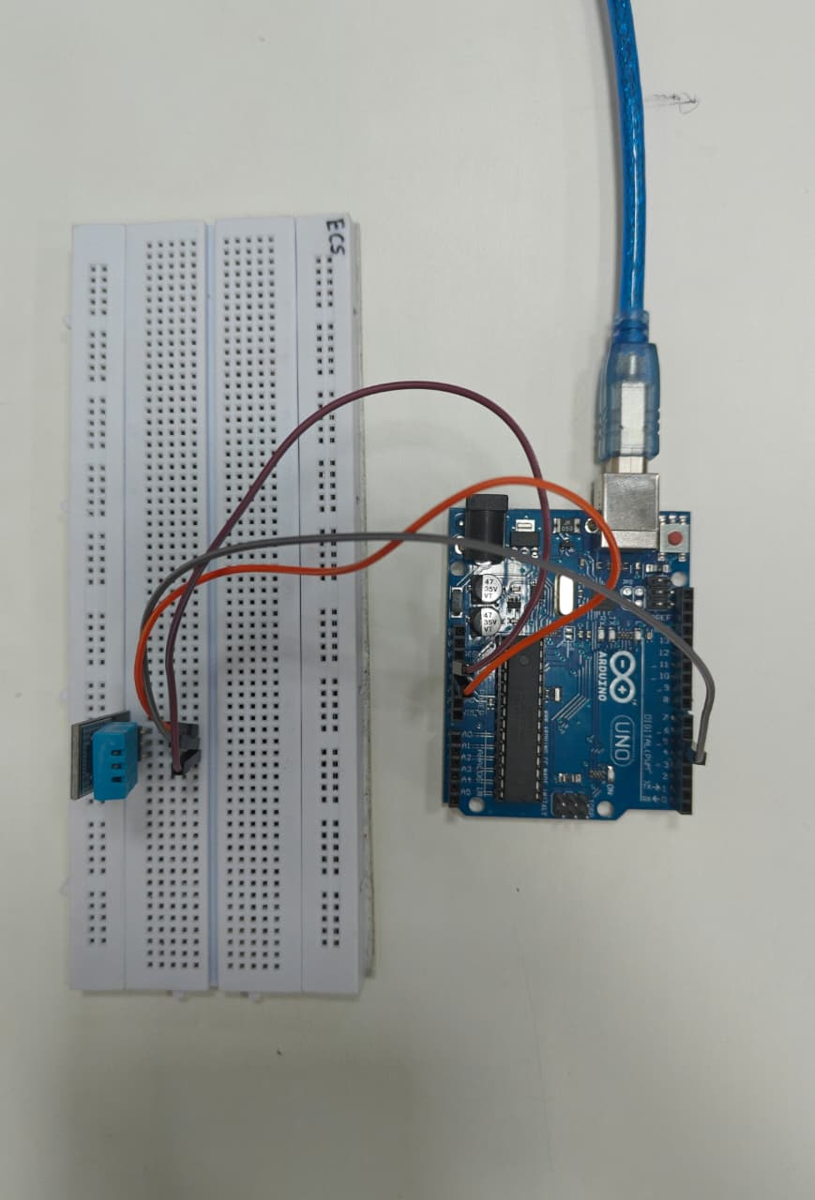
Code
#include <DHT.h>

#define DHTPIN 2
#define DHTTYPE DHT11

DHT dht(DHTPIN, DHTTYPE);

void setup() {
Serial.begin(9600);
dht.begin();
Serial.println("DHT11 Sensor Reading");
}

void loop() {
float humidity = dht.readHumidity();
float temperature = dht.readTemperature();

if (isnan(humidity) || isnan(temperature)) {
Serial.println("Failed to read from DHT sensor!");
return;
}

Serial.print("Humidity: ");
Serial.print(humidity);
Serial.print(" %\t");

Serial.print("Temperature: ");
Serial.print(temperature);
Serial.println(" °C");

delay(2000);
}

Procedure
- Connect circuit
- Open Arduino IDE
- Install DHT library
- Select board & port
- Upload code
- Open Serial Monitor (9600 baud)
- Observe readings
Observation
Parameter | Value
Temperature | ~24–25°C
Humidity | ~35–40%
Conclusion
DHT11 sensor was successfully interfaced with Arduino, and temperature & humidity values were displayed, demonstrating sensor communication and real-time data acquisition.’

🔬 EXPERIMENT 3: Interfacing Seven Segment Display with Arduino
📄 Source:
Aim
To interface a seven-segment display with Arduino and display digits 0–9 sequentially.
Apparatus Required
- Arduino Uno
- Seven Segment Display (CA/CC)
- 220Ω resistors
- Breadboard
- Jumper wires
- USB cable
Theory
- A seven-segment display has 7 LEDs (a–g) + decimal point
- Used to display numbers (0–9)
Types
- Common Cathode (CC) → segments ON when HIGH
- Common Anode (CA) → segments ON when LOW
Pin Configuration (Example)
Segment | Pin
a | 7
b | 6
c | 4
d | 2
e | 1
f | 9
g | 10
Common → GND (CC) / VCC (CA)
Algorithm
- Start
- Configure segment pins as OUTPUT
- Define patterns for digits (0–9)
- Display each digit
- Add delay
- Repeat
Code
unsigned const int A = 13;
unsigned const int B = 12;
unsigned const int C = 11;
unsigned const int D = 10;
unsigned const int E = 9;
unsigned const int F = 8;
unsigned const int G = 7;
unsigned const int H = 6;
void setup(void)
{
pinMode(A, OUTPUT);
pinMode(B, OUTPUT);
pinMode(C, OUTPUT);
pinMode(D, OUTPUT);
pinMode(E, OUTPUT);
pinMode(F, OUTPUT);
pinMode(G, OUTPUT);
pinMode(H, OUTPUT);
}
void zero(void) {
digitalWrite(A, LOW);
digitalWrite(B, HIGH);
digitalWrite(C, HIGH);
digitalWrite(D, HIGH);
digitalWrite(E, HIGH);
digitalWrite(F, HIGH);
digitalWrite(G, HIGH);
digitalWrite(H, LOW);
}
void one(void) {
digitalWrite(A, LOW);
digitalWrite(B, LOW);
digitalWrite(C, LOW);
digitalWrite(D, HIGH);
digitalWrite(E, LOW);
digitalWrite(F, LOW);
digitalWrite(G, HIGH);
digitalWrite(H, LOW);
}
void two(void) {
digitalWrite(A, HIGH);
digitalWrite(B, LOW);
digitalWrite(C, HIGH);
digitalWrite(D, HIGH);
digitalWrite(E, HIGH);
digitalWrite(F, HIGH);
digitalWrite(G, LOW);
digitalWrite(H, LOW);
}
void three(void) {
digitalWrite(A, HIGH);
digitalWrite(B, LOW);
digitalWrite(C, HIGH);
digitalWrite(D, HIGH);
digitalWrite(E, LOW);
digitalWrite(F, HIGH);
digitalWrite(G, HIGH);
digitalWrite(H, LOW);
}
void four(void) {
digitalWrite(A, HIGH);
digitalWrite(B, HIGH);
digitalWrite(C, LOW);
digitalWrite(D, HIGH);
digitalWrite(E, LOW);
digitalWrite(F, LOW);
digitalWrite(G, HIGH);
digitalWrite(H, LOW);
}
void five(void) {
digitalWrite(A, HIGH);
digitalWrite(B, HIGH);
digitalWrite(C, HIGH);
digitalWrite(D, LOW);
digitalWrite(E, LOW);
digitalWrite(F, HIGH);
digitalWrite(G, HIGH);
digitalWrite(H, LOW);
}
void six(void) {
digitalWrite(A, HIGH);
digitalWrite(B, HIGH);
digitalWrite(C, HIGH);
digitalWrite(D, LOW);
digitalWrite(E, HIGH);
digitalWrite(F, HIGH);
digitalWrite(G, HIGH);
digitalWrite(H, LOW);
}
void seven(void) {
digitalWrite(A, LOW);
digitalWrite(B, LOW);
digitalWrite(C, HIGH);
digitalWrite(D, HIGH);
digitalWrite(E, LOW);
digitalWrite(F, LOW);
digitalWrite(G, HIGH);
digitalWrite(H, LOW);
}
void eight(void) {
digitalWrite(A, HIGH);
digitalWrite(B, HIGH);
digitalWrite(C, HIGH);
digitalWrite(D, HIGH);
digitalWrite(E, HIGH);
digitalWrite(F, HIGH);
digitalWrite(G, HIGH);
digitalWrite(H, LOW);
}

void nine(void) {
digitalWrite(A, HIGH);
digitalWrite(B, HIGH);
digitalWrite(C, HIGH);
digitalWrite(D, HIGH);
digitalWrite(E, LOW);
digitalWrite(F, HIGH);
digitalWrite(G, HIGH);
digitalWrite(H, LOW);
}
void loop(void)
{
zero();
delay(100);
one();
delay(100);
two();
delay(100);
three();
delay(100);
four();
delay(100);
five();
delay(100);
six();
delay(100);
seven();
delay(100);
eight();
delay(100);
nine();
delay(100);
}

Procedure
- Connect segments via resistors
- Identify CA/CC type
- Upload code
- Observe digits

Observation
Digit | Segments ON
0 | a b c d e f
1 | b c
2 | a b d e g
3 | a b c d g
4 | b c f g
5 | a c d f g
6 | a c d e f g
7 | a b c
8 | a b c d e f g
9 | a b c d f g

Conclusion
Seven-segment display successfully interfaced and digits 0–9 displayed, demonstrating control of multiple output pins.
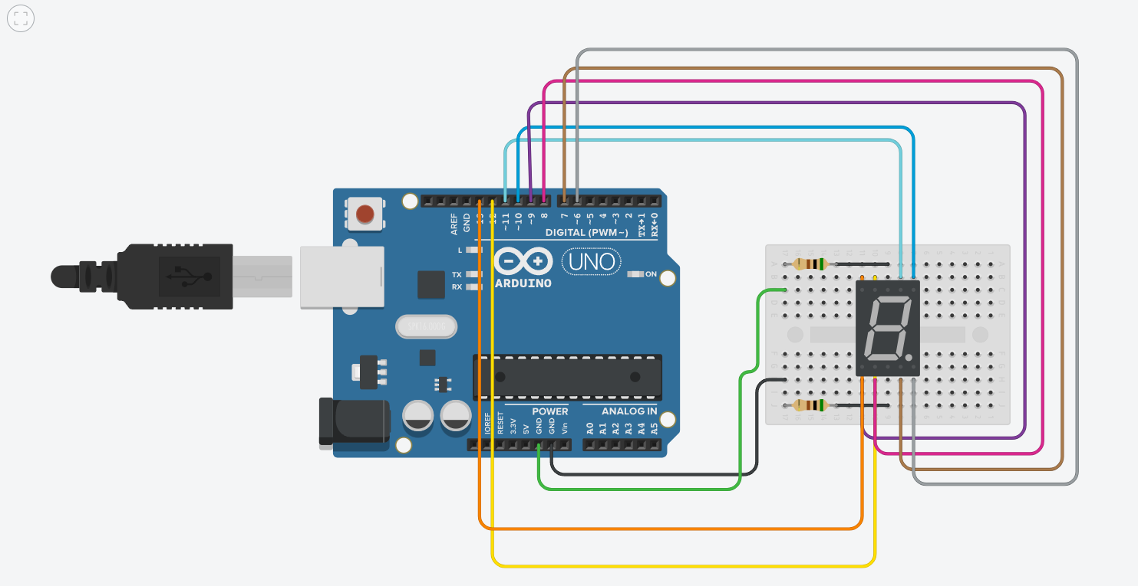

🔬 EXPERIMENT 4: Interfacing LCD 16×2 using I2C with Arduino
📄 Source:

Aim
To interface a 16×2 LCD display using I2C module with Arduino and display text.

Apparatus Required
- Arduino Uno
- 16×2 LCD with I2C module
- Breadboard
- Connecting wires
- USB cable

Theory
LCD Basics
- LCD displays characters using liquid crystals
- Controlled by internal controller
I2C Communication
- Uses only 2 lines:
  - SDA (Data)
  - SCL (Clock)
- Arduino acts as master
- LCD acts as slave
👉 Reduces wiring compared to parallel LCD

Connections
LCD Pin | Arduino
VCC | 5V
GND | GND
SDA | A4
SCL | A5

Algorithm
- Start
- Initialize LCD
- Turn ON backlight
- Set cursor position
- Display text
- Repeat

Program Code
#include <LiquidCrystal_I2C.h>
LiquidCrystal_I2C lcd(0x20,16,2);
void setup()
{
lcd.init();
lcd.clear();
lcd.backlight(); // Make sure backlight is on
lcd.setCursor(2,0); //Set cursor to character 2 on line 0
lcd.print("TE-ECS");
lcd.setCursor(2,1); //Move cursor to character 2 on line 1
lcd.print("GG Guys");
}
void loop()
{
}
Circuit
Agar Code nai chalra to library and boards check karna
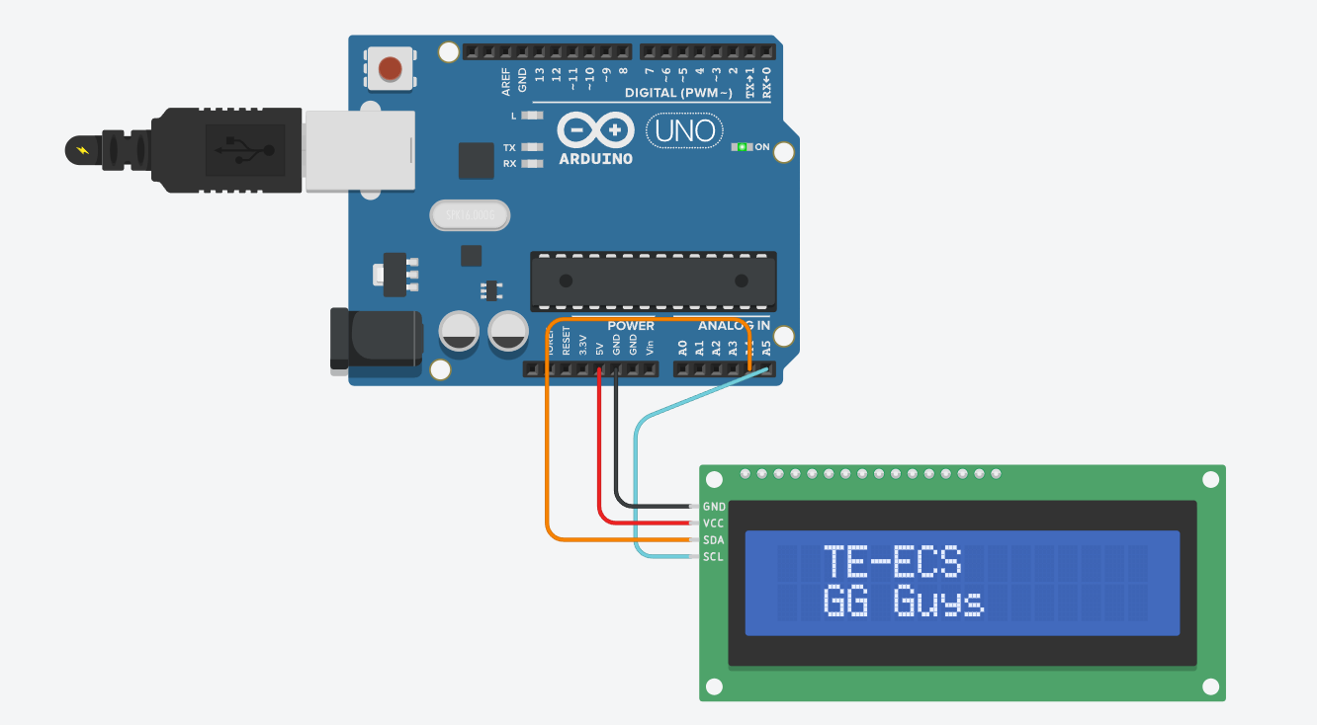
Procedure
- Connect LCD via I2C
- Install LiquidCrystal_I2C library
- Upload code
- Observe display

Conclusion
LCD was successfully interfaced using I2C, reducing wiring complexity and demonstrating serial communication in embedded systems.

🔬 EXPERIMENT 5 (MODIFIED): Ultrasonic Sensor with STM32 using Arduino IDE
(Same hardware, just ditching CubeIDE drama)

Aim
To interface and program HC-SR04 Ultrasonic Sensor with STM32 using Arduino IDE to measure distance.
Apparatus Required
- STM32 (Blue Pill / similar)
- HC-SR04 Ultrasonic Sensor
- Breadboard
- Jumper wires
- USB / ST-Link (for upload)
- Arduino IDE

Theory (Same — no need to reinvent physics)
- Ultrasonic sensor sends sound waves
- Measures echo return time
- Calculates distance
$$Distance=\frac{Time×0.0343}{2}$$
Connections (Same Hardware)
Sensor | STM32
VCC | 5V
GND | GND
TRIG | PA1
ECHO | PA2
⚠ If your board isn’t 5V tolerant → use voltage divider on ECHO
Algorithm
- Set TRIG as OUTPUT
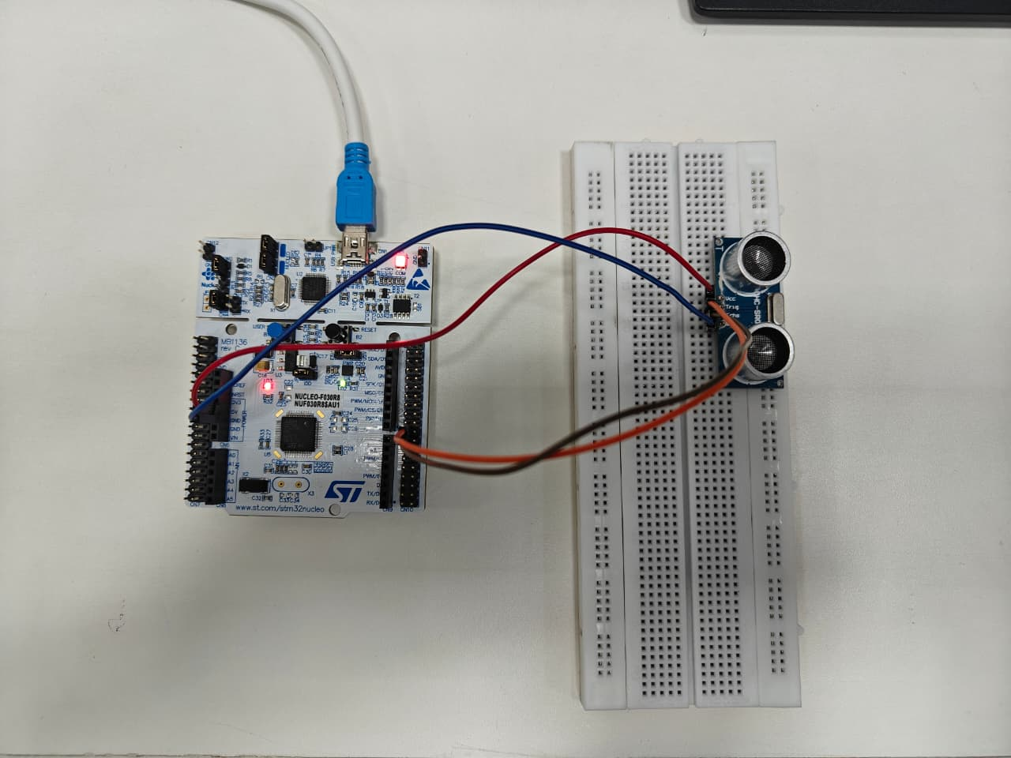
- Set ECHO as INPUT
- Send 10 µs pulse
- Measure echo duration
- Convert to distance
- Print on Serial Monitor
Circuit

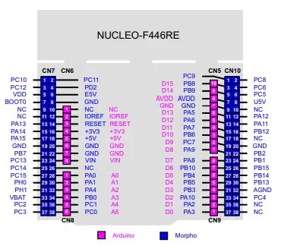
I don’t know stm32 exps just pray you wont get one
Code
#define TRIG PA1
#define ECHO PA2
long duration;
float distance;
void setup() {
pinMode(TRIG, OUTPUT);
pinMode(ECHO, INPUT);
Serial.begin(9600);
}
void loop() {
// Clear trigger
digitalWrite(TRIG, LOW);
delayMicroseconds(2);

// Send pulse
digitalWrite(TRIG, HIGH);
delayMicroseconds(10);
digitalWrite(TRIG, LOW);

// Read echo
duration = pulseIn(ECHO, HIGH);

// Calculate distance
distance = (duration * 0.0343) / 2;

// Print output
Serial.print("Distance: ");
Serial.print(distance);
Serial.println(" cm");

delay(500);
}

Procedure (Modified for Arduino IDE)
- Install STM32 board package in Arduino IDE
- Select board (e.g., STM32F103C8)
- Select correct COM port
- Connect circuit
- Paste code
- Upload (via ST-Link or USB)
- Open Serial Monitor

Observation
- Distance displayed in Serial Monitor
- Values change with object movement

Expected Output
Distance: 12.4 cm
Distance: 25.1 cm
Distance: 8.7 cm

Conclusion
The ultrasonic sensor was successfully interfaced with STM32 using Arduino IDE, demonstrating simplified embedded programming while maintaining accurate distance measurement.

🔬 EXPERIMENT 6: Servo Motor Control using PWM (STM32)
📄 Source:

Aim
To interface and control the position of a servo motor using PWM signals generated by STM32.

Apparatus Required
- STM32 board (Nucleo/Blue Pill)
- SG90 Servo Motor
- Breadboard
- Jumper wires
- ST-Link / USB
- STM32CubeIDE / Arduino IDE

Theory
- Servo motor = precise position control device
- Controlled using PWM (Pulse Width Modulation)
PWM Basics
- Frequency ≈ 50 Hz
- Pulse width controls angle:
Pulse Width | Angle
1 ms | 0°
1.5 ms | 90°
2 ms | 180°
STM32 timers generate PWM signals to control position

Connections
Servo Wire | Connection
Red | 5V
Brown/Black | GND
Orange/Yellow | PWM Pin (PA0 / TIM2_CH1)

Algorithm
- Initialize PWM
- Set frequency = 50 Hz
- Generate PWM signal
- Vary duty cycle
- Servo rotates accordingly
- Repeat
Program Code (Arduino IDE – STM32)
#define SERVO_PIN PA0

void setup() {
pinMode(SERVO_PIN, OUTPUT);
}

void setAngle(int angle) {
int pulseWidth = map(angle, 0, 180, 1000, 2000); // µs
digitalWrite(SERVO_PIN, HIGH);
delayMicroseconds(pulseWidth);
digitalWrite(SERVO_PIN, LOW);
delay(20 - pulseWidth / 1000); // maintain 20ms period
}

void loop() {
setAngle(0);
delay(1000);

setAngle(90);
delay(1000);

setAngle(180);
delay(1000);
}
Circuit:
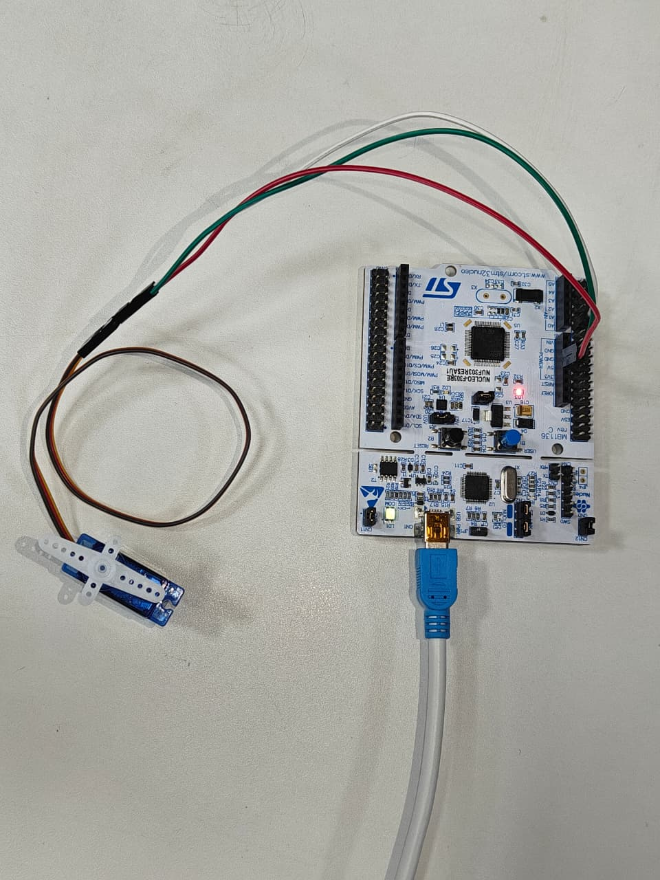
Nai run hua to bolo Motor ki galti hai code sahih ai motor nai chalra
Procedure
- Connect servo to STM32
- Configure PWM pin
- Upload code
- Observe servo movement

Observation
- Servo rotates to:
  - 0°
  - 90°
  - 180°

Conclusion
Servo motor position successfully controlled using PWM signals generated by STM32, demonstrating precise motor control.

🔬 EXPERIMENT 7: Multiple Task Creation in FreeRTOS
📄 Source:

Aim
To create multiple tasks and understand task management feature of FreeRTOS.

Theory
RTOS Concept
- Only one task runs at a time
- Scheduler switches between tasks
- Gives illusion of multitasking

FreeRTOS
- Lightweight RTOS for microcontrollers
- Provides:
  - Task scheduling
  - Inter-task communication
  - Synchronization

Task
- A task = independent function
- Runs in loop
- Has its own stack

Algorithm
- Start
- Create multiple tasks
- Assign priorities
- Start scheduler
- Tasks execute in switching manner

Program Code (Basic Example)
#include <Arduino.h>
#include <STM32FreeRTOS.h>

#define LED_PIN PA5

// Task 1: LED Blinking
void TaskLED(void *pvParameters) {
pinMode(LED_PIN, OUTPUT);

while (1) {
digitalWrite(LED_PIN, HIGH);
vTaskDelay(pdMS_TO_TICKS(500));

digitalWrite(LED_PIN, LOW);
vTaskDelay(pdMS_TO_TICKS(500));
}
}

// Task 2: Serial Printing
void TaskSerial(void *pvParameters) {
while (1) {
Serial.println("FAhhhhhhhhh...");
vTaskDelay(pdMS_TO_TICKS(1000));
}
}

void setup() {
Serial.begin(115200);

// Create Task 1 (LED)
xTaskCreate(TaskLED, "LED Task", 128, NULL, 1, NULL);

// Create Task 2 (Serial)
xTaskCreate(TaskSerial, "Serial Task", 128, NULL, 1, NULL);

// Start FreeRTOS Scheduler
vTaskStartScheduler();
}

void loop() {
// Not used
}
Circuit? Bas stm connect karlo
Conclusion
Multiple tasks were successfully created and executed using FreeRTOS, demonstrating multitasking and scheduler operation.

🔬 EXPERIMENT 8: Task Scheduling in FreeRTOS
📄 Source:

Aim
To illustrate task scheduling feature of FreeRTOS using multiple tasks.

Theory (From Your File, Cleaned)
- Task = independent function
- Multiple tasks share CPU
- Scheduler decides:
  - which task runs
  - when it runs
  - based on priority & state
Task States
- Running
- Ready
- Blocked
- Suspended

Scheduling Concepts
- Priority-based scheduling
  - Higher priority → executes first
- Preemptive scheduling
  - High priority task interrupts low priority
- Time slicing
  - Same priority → CPU shared equally

Program Code (Your Experiment)
/ --- Task Scheduler Experiment: Nucleo-F303RE ---
// Definitions for Task 2 and Task 3
const int externalLed = PA10; // D2 header
const int buzzerPin = PB3; // D3 header
void setup() {
// Initialize Pins
pinMode(LED_BUILTIN, OUTPUT);
pinMode(externalLed, OUTPUT);
pinMode(buzzerPin, OUTPUT);
// Initialize Task 4: Serial Communication
Serial.begin(9600);
while (!Serial); // Ensure monitor is ready
Serial.println("========================================");
Serial.println(" STM32 TASK SCHEDULER EXPERIMENT ");
Serial.println("========================================");
}
void loop() {
// --- TASK 1: Onboard LED Control ---
Serial.print("Executing Task 1... ");
digitalWrite(LED_BUILTIN, HIGH);
delay(400);
digitalWrite(LED_BUILTIN, LOW);
Serial.println("[DONE: Onboard LED Blinked]");
// --- TASK 2: External LED Control ---
Serial.print("Executing Task 2... ");
digitalWrite(externalLed, HIGH);
delay(400);
digitalWrite(externalLed, LOW);
Serial.println("[DONE: External LED Blinked]");
// --- TASK 3: Buzzer Sound Control ---
Serial.print("Executing Task 3... ");
digitalWrite(buzzerPin, HIGH);
delay(150); // Short beep
digitalWrite(buzzerPin, LOW);
Serial.println("[DONE: Buzzer Beeped]");
// --- TASK 4: Scheduler Status Report ---
Serial.println(">> STATUS: Full Cycle Completed Successfully.");
Serial.println("----------------------------------------");
// Gap between cycles
delay(1500);
}
Component | STM32 Pin | Wire Color (approx)
External LED | PA10(D2) | Green/Yellow
Buzzer | PB3(D3) | Dark wire
GND | GND | Red/Black wires
Onboard LED | PA5 | Built-in

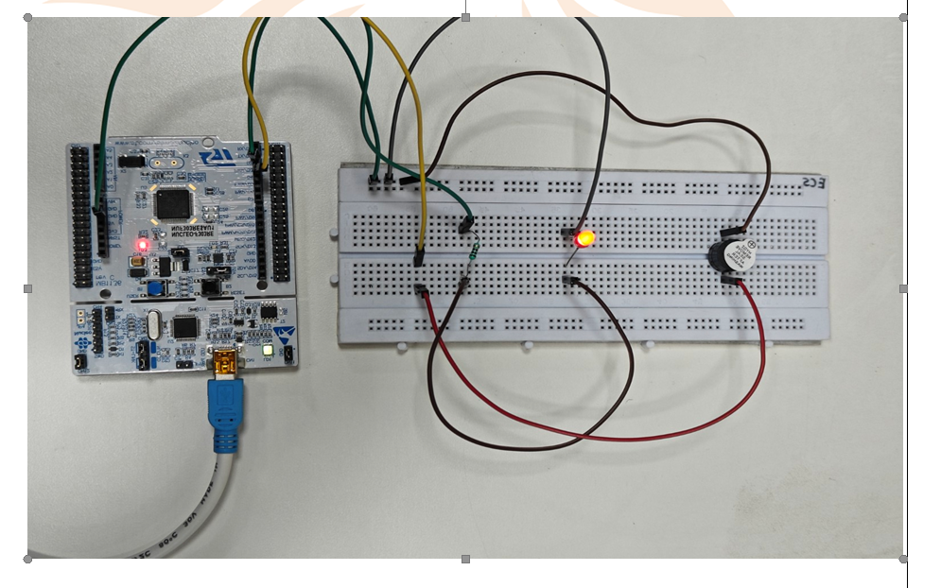
Procedure
- Connect LEDs and buzzer
- Upload code
- Observe sequential execution

Observation
- LED1 → LED2 → Buzzer
- Repeats continuously
- Looks like multitasking

Conclusion
Task scheduling behavior was demonstrated, showing how multiple tasks can be executed in sequence, simulating multitasking.

🔬 EXPERIMENT 9: Queue Management in FreeRTOS
📄 Source:

Aim
To illustrate queue management feature of FreeRTOS for inter-task communication.

Theory
- Queue = FIFO (First In First Out) structure
- Used for safe communication between tasks
- One task sends data → another receives
Key Features
- Thread-safe
- Blocking support (wait if empty/full)
- Supports multiple tasks
- ISR-safe functions available

Working Concept
- Sender task → sends data to queue
- Receiver task → reads data
- Ensures no data conflict

Program Code (Your Experiment)
#include <Arduino.h>
#include <STM32FreeRTOS.h>

// 1. Create a queue handle [cite: 31]
QueueHandle_t myQueue;

// --- SENDER TASK --- [cite: 32]
void senderTask(void *pvParameters) {
int count = 0; // [cite: 34]
while (1) {
count++; // [cite: 36]

// Send data to queue [cite: 37]
// Uses portMAX_DELAY to wait if queue is full [cite: 15, 38]
xQueueSend(myQueue, &count, portMAX_DELAY);

Serial.print("Sent: "); // [cite: 39]
Serial.println(count); // [cite: 40]

vTaskDelay(1000 / portTICK_PERIOD_MS); // 1 second delay [cite: 41]
}
}

// --- RECEIVER TASK --- [cite: 44]
void receiverTask(void *pvParameters) {
int receivedValue; // [cite: 46]
while (1) {
// Receive data from queue [cite: 48, 49]
if (xQueueReceive(myQueue, &receivedValue, portMAX_DELAY)) {
Serial.print("Received: "); // [cite: 50]
Serial.println(receivedValue); // [cite: 51]
}
}
}

void setup() {
Serial.begin(9600); // [cite: 56]

// 2. Initialize the Queue: 5 elements, each of int type [cite: 57, 58]
myQueue = xQueueCreate(5, sizeof(int));

if (myQueue == NULL) { // [cite: 59]
Serial.println("Queue creation failed!"); // [cite: 60]
while (1); // [cite: 61]
}

// 3. Create tasks [cite: 63, 64, 65]
xTaskCreate(senderTask, "Sender", 128, NULL, 1, NULL);
xTaskCreate(receiverTask, "Receiver", 128, NULL, 1, NULL);

// 4. Start the scheduler [cite: 66, 67]
vTaskStartScheduler();
}

void loop() {
// Empty: FreeRTOS handles everything [cite: 69, 70]
}

Circuit connect stm
And hope it works
Procedure
- Create queue using xQueueCreate()
- Create sender & receiver tasks
- Upload code
- Open Serial Monitor
- Observe data transfer

Observation
Sent: 1
Received: 1
Sent: 2
Received: 2
Sent: 3
Received: 3

Conclusion
Queue successfully enabled safe and synchronized data transfer between tasks, demonstrating inter-task communication in FreeRTOS.

🔬 EXPERIMENT 10: Binary & Counting Semaphore in FreeRTOS
📄 Source:

Aim
To illustrate the use of Binary and Counting Semaphores for task synchronization in FreeRTOS.

Theory
Semaphore
- Used for task synchronization & resource sharing

Binary Semaphore
- Value = 0 or 1
- Used for signaling
- Example:
  - Task waits
  - Another task/ISR signals

Counting Semaphore
- Value = 0 to N
- Used for multiple resources
- Allows limited number of tasks to access resource

Key Functions
- xSemaphoreCreateBinary()
- xSemaphoreCreateCounting()
- xSemaphoreTake() → acquire
- xSemaphoreGive() → release

Program Code

🔹 Part A: Binary Semaphore
#include <STM32FreeRTOS.h>

// --- GLOBAL DECLARATIONS ---
// These must be outside setup() so all functions can see them
SemaphoreHandle_t xBinarySemaphore;

// Function Prototypes (telling the compiler these exist)
void TaskProducer(void *pvParameters);
void TaskConsumer(void *pvParameters);

void setup() {
Serial.begin(9600);
while (!Serial);

pinMode(PA5, OUTPUT); // Onboard LED

Serial.println("--- FreeRTOS Binary Semaphore Experiment ---");

// 1. Create the Semaphore
xBinarySemaphore = xSemaphoreCreateBinary();

if (xBinarySemaphore != NULL) {
// 2. Create Tasks
xTaskCreate(TaskProducer, "Producer", 128, NULL, 2, NULL);
xTaskCreate(TaskConsumer, "Consumer", 128, NULL, 1, NULL);

// 3. Start Scheduler
vTaskStartScheduler();
}
}

void loop() {
// Should be empty!
}

// --- TASK 1: PRODUCER ---
void TaskProducer(void *pvParameters) {
for (;;) {
Serial.println("Producer: Giving Semaphore...");
xSemaphoreGive(xBinarySemaphore);
vTaskDelay(pdMS_TO_TICKS(2000)); // Wait 2 seconds
}
}

// --- TASK 2: CONSUMER ---
void TaskConsumer(void *pvParameters) {
for (;;) {
// Wait for the flag
if (xSemaphoreTake(xBinarySemaphore, portMAX_DELAY) == pdTRUE) {
Serial.println("Consumer: Semaphore Taken! LED ON.");
digitalWrite(PA5, HIGH);
vTaskDelay(pdMS_TO_TICKS(200));
digitalWrite(PA5, LOW);
}
}
}
🔹 Part B: Counting Semaphore
Ye 8th wala circuit hai lekin code change kie hai
Ya wo bhi kie nai pata
#include <STM32FreeRTOS.h>

// --- Definitions ---
const int externalLed = PA10; // D2
const int buzzerPin = PB3; // D3

// Declare Counting Semaphore Handle
SemaphoreHandle_t xCountingSemaphore;

void TaskProducer(void *pvParameters);
void TaskConsumer(void *pvParameters);

void setup() {
Serial.begin(9600);
while (!Serial);

// Initialize Hardware
pinMode(PA5, OUTPUT);
pinMode(externalLed, OUTPUT);
pinMode(buzzerPin, OUTPUT);

Serial.println("--- Scheduler with Counting Semaphore ---");

// Create Semaphore: Max 3 tokens (one for each hardware task)
xCountingSemaphore = xSemaphoreCreateCounting(3, 0);

if (xCountingSemaphore != NULL) {
xTaskCreate(TaskProducer, "Producer", 128, NULL, 2, NULL);
xTaskCreate(TaskConsumer, "Consumer", 128, NULL, 1, NULL);
vTaskStartScheduler();
}
}

void loop() {}

// --- TASK 1: THE PRODUCER (Triggers the Sequence) ---
void TaskProducer(void *pvParameters) {
for (;;) {
Serial.println("\nProducer: Releasing 3 Tokens for the Hardware Cycle...");

// Give 3 tokens to signal that 3 tasks are ready to run
xSemaphoreGive(xCountingSemaphore);
xSemaphoreGive(xCountingSemaphore);
xSemaphoreGive(xCountingSemaphore);

vTaskDelay(pdMS_TO_TICKS(5000)); // Wait 5 seconds between cycles
}
}
void TaskConsumer(void *pvParameters) {
int taskCount = 0;
for (;;) {
if (xSemaphoreTake(xCountingSemaphore, portMAX_DELAY) == pdTRUE) {
taskCount++;

if (taskCount == 1) {
Serial.println("Consumer: Task 1 - Onboard LED");
digitalWrite(PA5, HIGH); vTaskDelay(pdMS_TO_TICKS(500)); digitalWrite(PA5, LOW);
}
else if (taskCount == 2) {
Serial.println("Consumer: Task 2 - External LED");
digitalWrite(externalLed, HIGH); vTaskDelay(pdMS_TO_TICKS(500)); digitalWrite(externalLed, LOW);
}
else if (taskCount == 3) {
Serial.println("Consumer: Task 3 - Buzzer Beep");
digitalWrite(buzzerPin, HIGH); vTaskDelay(pdMS_TO_TICKS(200)); digitalWrite(buzzerPin, LOW);
taskCount = 0; // Reset for the next cycle
Serial.println(">> Full Scheduler Cycle Complete!");
}
}
}

}

Procedure
- Create semaphore
- Create producer & consumer tasks
- Upload program
- Observe synchronization

Observation
- Binary:
  - Task waits → signal received → executes
- Counting:
  - Limited tasks execute based on count

Conclusion
Binary semaphore enables task signaling, while counting semaphore manages multiple resources and controls task execution efficiently.

